NORTHERN ILLINOIS UNIVERSITY
DE KALB, ILLINOIS

[MAY/AUGUST/DECEMBER 2030]

[REPLACE THIS TEXT WITH THE FULL TITLE AND SUBTITLE OF YOUR DOCUMENT AND ENSURE THAT IT IS DOUBLE SPACED]

BY
[VICTOR E. HUSKIE]
©[2030 Victor E. Huskie]

A [THESIS/DISSERTATION] SUBMITTED TO THE GRADUATE SCHOOL
IN PARTIAL FULFILLMENT OF THE REQUIREMENTS
FOR THE DEGREE
[MASTER OF ARTS/MUSIC/SCIENCE or DOCTOR OF EDUCATION/PHILOSOPHY]

[NAME OF DEPARTMENT]

[THESIS/DOCTORAL] DIRECTOR:
[FIRST AND LAST NAME]

ABSTRACT
[Replace text within brackets with your abstract. Use size 12-point accessible font. The heading centered above is "NIU MAJOR HEADING" in Word's "Styles" in this template.]
[Begin each new paragraph with a single tab, 0.5-inch indentation. Double-space your text. Text must be left-aligned and not fully justified.]
[This is page 2 and the first page with a visible page number. Arabic pagination continues from this point through the last page of the document. There is no word limit for abstracts, but the recommended length is 250 words or fewer. Do not include citations, images, or footnotes in your abstract.]

ACKNOWLEDGEMENTS (Optional)
[Replace text within brackets with your acknowledgements if you choose to include them. If not, delete this page. Use size 12-point accessible font. The heading centered above is "NIU MAJOR HEADING" in Word's "Styles" in this template.]
[Begin each new paragraph with a single tab, 0.5-inch indentation. Double-space your text. Text must be left-aligned and not fully justified.]

DEDICATION (Optional)
[Replace text within brackets with your dedication if you choose to include one. If not, delete this page. Use size 12-point accessible font. The heading centered above is "NIU MAJOR HEADING" in Word's "Styles" in this template. Dedication must be centered under the heading and is typically one to two lines long.]

TABLE OF CONTENTS
ABSTRACT 2
ACKNOWLEDGEMENTS (Optional) 3
DEDICATION (Optional) 4
TABLE OF CONTENTS 5
LIST OF TABLES (OPTIONAL) 6
LIST OF FIGURES (OPTIONAL) 7
LIST OF [SYMBOLS/ABBREVIATIONS] (OPTIONAL) 8
PREFACE (OPTIONAL) 9
CHAPTER 1: [REPLACE WITH YOUR MAJOR HEADING] 10
[Replace With Your Level 1 Subheading] 10
[Replace With Your Level 2 Subheading] 12
[Replace With Your Level 3 Subheading] 12
[Replace With Your Level 4 Subheading] 12
[Replace With Your Level 5 Subheading] 12
REFERENCES 14
APPENDIX A: [REPLACE WITH YOUR APPENDIX TITLE] (OPTIONAL) 15

LIST OF TABLES (OPTIONAL)
Table 1: [Replace With Your Table Label] 13

LIST OF FIGURES (OPTIONAL)
Figure 1: [Replace With Your Figure Label] 11

LIST OF [SYMBOLS/ABBREVIATIONS] (OPTIONAL)
[AAA American Anthropological Association
ACS American Chemical Society
AMA American Medical Association
AMS American Mathematical Society
AND Academy of Nutrition and Dietetics
APA American Psychological Association
ASA American Sociological Association
ASME American Society of Mechanical Engineers
CMOS Chicago Manual of Style
CSE Council of Science Editors
IEEE Institute of Electrical and Electronics Engineers
MLA Modern Language Association]

PREFACE (OPTIONAL)
[Replace text within brackets with your preface, if needed. If not, delete this page. Use size 12-point accessible font. The heading centered above is "NIU MAJOR HEADING" in Word's "Styles" in this template.]
[Begin each new paragraph with a single tab, 0.5-inch indentation. Double-space your text. Text must be left-aligned and not fully justified.]
[The preface is optional. It includes explanatory remarks about the background of the work and is often used in dissertations of practice.]

CHAPTER 1: [REPLACE WITH YOUR MAJOR HEADING]
[Replace text within brackets with the main text of your document. Use size 12-point accessible font. The heading centered above is "NIU MAJOR HEADING" in Word's "Styles" in this template.]
[Begin each new paragraph with a single tab, 0.5-inch indentation. Double-space your text. Text must be left-aligned and not fully justified.]
[Each chapter of your document must begin on a new page with a centered, all-caps, bold MAJOR HEADING. Change the chapter number to correctly label each of your chapters and replace the bracketed text with the appropriate chapter title.]

[Replace With Your Level 1 Subheading]
[Subheadings follow APA and are preset in Word's "Styles" in this template. They are labeled as "NIU Level 1 Subheading," "NIU Level 2 Subheading," and so on, through level 5. Some documents might use one or two levels of subheadings, while others may use more. Keep track of the levels within your paper and select the appropriate subheading numbers in "Styles." Level 1 Subheadings are centered, bold, and in title case.]
[Tables and figures, if used, must be accessible, numbered consecutively, and labeled consistently. They may be numbered simply through the entire document (1, 2, 3, etc.) or may utilize the decimal system in which the number before the decimal indicates the chapter, and the number after the decimal indicates the item number.]
[Table and figure numbers/labels and captions/notes must be left-aligned and single-spaced. Tables and figures must be labeled above, but their captions/notes can be below. Tables and figures that continue on subsequent pages should indicate that they do so at the top of the continuation, e.g., "Table 1 (continued)," "Fig. 3 (cont.)," or similar. Wide tables and figures may be displayed horizontally on landscape pages where their numbers/labels, captions/notes, and page numbers are also rotated.]
[All figures must have alt text, which acts as a direct substitute for the visual content and can be read aloud by assistive technology.]
Figure 1: [Replace With Your Figure Label]
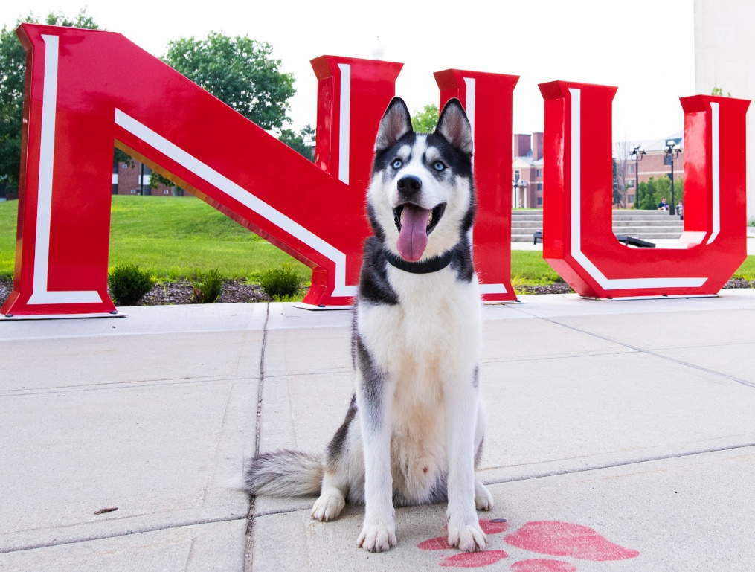
Note: Notes are optional and provide explanatory or contextual information about the figures they accompany. They are single-spaced.

[Replace With Your Level 2 Subheading]
[Some documents might use one or two levels of subheadings, while others may use more. Keep track of the levels within your paper and select the appropriate subheading numbers in "Styles." Level 2 Subheadings are left-aligned, bold, and in title case.]

[Replace With Your Level 3 Subheading]
[Some documents might use one or two levels of subheadings, while others may use more. Keep track of the levels within your paper and select the appropriate subheading numbers in "Styles." Level 3 Subheadings are left-aligned, bold, title case, and italic.]
[Replace With Your Level 4 Subheading]. [Some documents might use one or two levels of subheadings, while others may use more. Keep track of the levels within your paper and select the appropriate subheading numbers in "Styles." Level 4 Subheadings are indented, bold, title case, and end with a period.]
[Replace With Your Level 5 Subheading]. [Some documents might use one or two levels of subheadings, while others may use more. Keep track of the levels within your paper and select the appropriate subheading numbers in "Styles." Level 5 Subheadings are indented, bold, title case, italic, and end with a period.]
[Tables must have row and/or column headers and must be simple in structure. Do not use merged/split cells or multi-level/split labels. Font within a table may be as small as 8-point. A table should not extend across two pages if it can easily fit on one page, and a long table should begin at the top of a page rather than in the middle or at the bottom of a page.]

Table 1: [Replace With Your Table Label]
Note: Notes are optional and provide explanatory or contextual information about the tables they accompany. They are single-spaced.

REFERENCES
[Author, A. A., Writer, W. W., Creator, C. C., & Name, N. N. (2027). Sources in a consistent documentation style of your choice: This example is in APA for a journal article. Journal Name in Title Case, 24(2), 18-32. https://doi.org/10.830283.3829.jntc.2027x.10.3]
[Creator, C. C., Writer, W. W., & Author, A. A. (2026). Pay attention to the type of source when creating citations: This example is in APA for a book. Publisher Name.]
[Government Agency or Organization Responsible. (2028, June). Webpage on a website with a government agency group author: Ensure it is not another type of source like a white paper, report, or fact sheet. Name of Parent Organization or Institute. https://www.domain.gov/health/topics/specific-condition/index.shtml]
[Name of Specific Organization or Agency Responsible. (2027). Name of the report: Including any potential subtitles (Publication No. 10-0001). Name of Parent Agency, Name of Another Parent Institute. https://www.domain.gov/publications/inserttheurllinkhere.pdf]
[Student, S. S. (2025). Dissertations and theses found online: Consider whether it was published in a national database or by the institution like NIU’s Huskie Commons (Publication No. 12369001) [Doctoral dissertation, Name of University]. Name of the Database.]
[Writer, W. W., & Author, A. (2028). Most titles for the source in APA use sentence capitalization: Only capitalize the first word, first word after a colon, and proper nouns. Journal Name in Title Case, 2028(12), 673-987. https://doi.org/10.0888.3829.jntc.2028x.12.4]

APPENDIX A: [REPLACE WITH YOUR APPENDIX TITLE] (OPTIONAL)
[Replace this text with your appendix material.]

